Distance Learning Lesson for
Music

Week 2 – Grade 1

Overview: Let’s have a variety of music experiences! Use the Music In Our Schools Month (MIOSM) Bingo sheet to complete as many short musical activities as you can!

Estimated Time: Approximately 25 minutes

Explanation: Enjoy an opportunity to choose your music learning activities from the MIOSM Bingo Board.

Three quick things to know:

- You can access the BINGO board on the next page below.
- You can print the board to keep track of the activities or write them down on a piece of paper as you complete them.

Tasks:
- Choose a family member or caregiver to help you print the BINGO board.
- Choose a row of tasks to complete! The row can be horizontal, vertical, or diagonal.
- Complete your chosen row and X off the boxes as you go!

Extension:
- Complete more than one row, or try to complete the whole board over the course of the week!
- You can also use the following links for more online learning fun: https://pbskids.org/games/music/

Method of Communication: Email at lgriffin@cbsd.org and let me know something new you learned, discovered, or taught someone! You could even send me a picture of your completed row(s). This is not required, but I’d love to hear from you!

Music in Our Schools Month (MIOSM) Bingo
What is your favorite song? Sing it to someone at home, or make a recording and send it to your teacher! | Name this instrument:  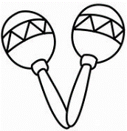  Look up some facts about it online. | Make an instrument out of recycled materials and email a picture to your music teacher. | Teach someone at home a song game that you learned in music class. Have fun playing it! | Tell this musical joke to a friend:  Q: Why did the girl sit on the ladder to sing?  A: She wanted to reach the high notes!
Sing a song in the bath or shower. What song did you sing? | Tell this musical joke to a friend:  Q: What part of the chicken is musical?  A: The drumstick! | What colors are the keys of a piano?  How many keys are on a grand piano?  Look up more facts about the piano. | Sing a song to a pet or a stuffed animal. What song did you sing? | Hum the tune of the “Alphabet Song” while you brush your teeth.
Where else can you hear music OUTSIDE of school? Make a list. | If you got free tickets to see any concert in the world, what group would you go see? | 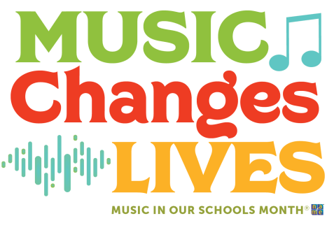 | Tell this musical joke to a family member:  Q: Where did the music teacher leave her keys?  A: In the piano! | Clap the rhythm pattern: 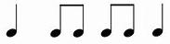  Try playing it on instruments or found objects. Try making up your own patterns.
How can music change someone’s life? Write down your ideas.  How has music changed your life? | Ask your family members what musical instruments they’ve ever played and why they chose that instrument! | Name this instrument. Look up some facts about it online.  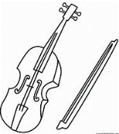 | Jump rope to the beat of a song. Can you sing it AND jump rope at the same time? | Tell this musical joke to a family member:  Q: What type of music are balloons scared of?  A: Pop music!
Play a hand-clapping game with a friend, family member or caregiver. | Wear a t-shirt that has music notes or a band’s name on it. | Watch a movie and pay special attention to the music in a certain scene. How did the music contribute to how you felt when watching it? | What is your best friend’s favorite song? | Fill in the blank: Fast or slow tells us __________.  (Choices: Dynamics, Tempo, Timbre, Rhythm)

Complete a row of your choice, in any direction (horizontal, vertical or diagonal).
For extra fun, complete an extra row or two!

